About Vulkan
Cross-platform API developed by Kronos group, who also developed OpenGL, that is specifically designed to work with more modern graphics cards. The advantage of it being fully cross-platform comes at a price, meaning the API code is much more verbose than something like OpenGL, and requires the programmer to do a lot more of the work that is mostly automatic in other APIs.
Older abstractions suffered from a couple problems; having fixed functionality (i.e. vertex data had to be in a standard format), and limited multi-threading support. Vulkan is verbose on purpose to allow the programmer to clearly specify their intent, so the GPU does not have to do guesswork to figure out the result. Vulkan also has support for multiple threads to create and submit commands in parallel. Another neat upgrade is standardized formatting for shader code, and a single shader compiler.

Hello, Triangle Steps

Step 1 – Instance Creation & Physical Device Selection
- Create a ‘VkInstance’
- Use the instance to query devices, and select the most fit one

Step 2 – Logical Device & Queue Families
- Create a ‘VkDevice’, described by ‘VkPhysicalDeviceFeatures’
- Most Vulkan operations are performed by submitting them to a ‘VkQueue’
  - These queues are described by ‘queue families’, each family then supports a specific set of operations

Step 3 – Window Surface & Swap Chain
- We need some way of creating a window, typically GLFW or SDL
- Each window needs a surface ‘VkSurfaceKHR’ and a swap chain ‘VkSwapchainKHR’
  - The ‘KHR’ suffix means they are part of an extension, as the core API is platform agnostic, for Windows we use the WSI extension
- The swap chain is basically a collection of render targets, where we specify how many targets are desired. When finished drawing to a target, the swap chain will ‘swap’ a finished image to present to the screen. Most common is double buffering for v-sync.

Step 4 – Image Views & Frame Buffers
- To draw to a swap chain image, we need to wrap it in ‘VkImageView’ and ‘VkFrameBuffer’
  - An image view represents a specific part of an image, i.e. colour or depth
  - A frame buffer references which image views are to be used, i.e. we may want a buffer that only draws to the depth component
  - Since image views / frame buffers do not tend to change after creation, we will create these alongside the swap chain

Step 5 – Render Passes
- Render passes describe what type of images to use during rendering operations
- For a basic triangle setup, we use a single colour target that is cleared every frame before we render to it
  - A render pass describes the types of images used, whereas a frame buffer binds specific images to these slots

Step 6 – Graphics Pipeline
- Create a ‘VkPipeline’ object, which describes the state of the GPU, such as viewport size, how to treat the depth buffer, and programmable states using ‘VkShaderModules’
  - The driver also needs to know the render targets used in each pipeline, which is specified by referencing a render pass
- Vulkan requires all configuration of each pipeline to be set in advance, so if we are switching to a different shader or change the vertex layout, we need to entirely re-create the pipeline object. While this is annoying, it is recommended to setup pre-determined pipelines at the get-go so switching is very efficient

Step 7 – Command Pools / Buffers
- Each operation submitted to the VkQueue must first be recorded into a ‘VkCommandBuffer’ and then submitted
- Each command buffer is allocated from a ‘VkCommandPool’ which is associated with a specific queue family
- To draw a simple triangle the recorded buffer would look like: begin render pass > bind pipeline > draw (3) vertices > end render pass
- Since the image in the frame buffer is dependent on the swap chain, we need to record a command buffer for every possible image. The alternative is to re-record the command buffer every frame which is highly inefficient

Step 8 – Main Loop
- Acquire image from the swap chain via ‘vkAcquireNextImageKHR’
- Select appropriate command buffer for that image and execute it with ‘vkQueueSubmit’
- Return image to swap chain to then present to screen with ‘vkQueuePresentKHR’
- Since queued operations are executed asynchronously, we need sync objects called ‘semaphores’ to ensure correct execution order
  - Semaphore 1 is set so the draw command buffer must wait for the image retrieval to finish, so we do not draw to an image already in use
  - Semaphore 2 is set so ‘vkQueuePresentKHR’ must wait for rendering to finish, so we again do not draw to an image already in use

Vulkan Coding Conventions
All Vulkan functions, enums and structs are defined in the ‘vulkan.h’ header file.
Prefixes:
- vk function
- Vk type (enum, struct)
- VK_ enum value
The Vulkan API uses structs to combine parameters for functions, for example most Vulkan objects follow this pattern:
VkXXXCreateInfo createParams = {
.sType = VK_STRUCTURE_TYPE_XXX_CREATE_INFO,
.pNext = nullptr,
.foo = …,
.bar = …
};

VkXXX object;
if (vkCreateXXX(&createParams, nullptr, &object) != VK_SUCCESS) {
std::cerr << “failed to create object X” << std::endl;
return false;
}

Functions that create or destroy objects will have ‘VkAllocationCallbacks’ parameters, which allow for custom allocators for driver memory. Very complex, should avoid .
Almost every Vulkan function returns ‘VK_SUCCESS’ or some error code, the docs specify exactly what each function can return and what each result means.

Validation Layers
Since Vulkan is designed for high performance & low overhead, there is very limited error checking or debugging. But Vulkan allows us to enable checks through ‘validation layers’, which can be enabled for development and then completely disabled for release builds for zero overhead.
It is possible to write your own validation layers, but usually these are provided for you. You can also, optionally, register a callback function to receive debug messages from these layers. Since Vulkan is so verbose, and these layers are so extensive, it is much easier to debug a black screen compared to OpenGL or Direct3d.

Dev Environment

Vulkan SDK
The SDK can be downloaded from the LunarG website, and once installed go to the install folder and run ‘Bin\vkcube.exe’ to test that our GPU supports Vulkan.
To check if you already have the SDK installed, you can run ‘vulkaninfo’ within a command prompt or terminal. This will tell you which version ‘VULKAN_SDK’ is set to.

GLFW
Since Vulkan is platform agnostic, as in it is designed to work on any platform, specifics like window creation must be offloaded to a third-party library like GLFW. You can opt to use SDL, but GLFW abstracts other platform specifics besides window creation.
GLFW can be downloaded from the official website, you can choose to use 64 or 32 bit, just be sure to link with the Vulkan SDL Lib or Lib32 appropriately.

GLM
Vulkan does not come pre-packaged with a linear algebra library, so we need to use a third-party one, usually people opt for GLM as it is a header-only library and very lightweight. You can download the latest version here.

Visual Studio Setup (for Windows)
- Create a C++ console application
- Paste the following into the main.cpp file
#define GLFW_INCLUDE_VULKAN
#include <GLFW/glfw3.h>

#define GLM_FORCE_RADIANS
#define GLM_FORCE_DEPTH_ZERO_TO_ONE
#include <glm/vec4.hpp>
#include <glm/mat4x4.hpp>

#include <iostream>

int main() {
glfwInit();

glfwWindowHint(GLFW_CLIENT_API, GLFW_NO_API);
GLFWwindow* window = glfwCreateWindow(800, 600, "Vulkan window", nullptr, nullptr);

uint32_t extensionCount = 0;
vkEnumerateInstanceExtensionProperties(nullptr, &extensionCount, nullptr);

std::cout << extensionCount << " extensions supported\n";

glm::mat4 matrix;
glm::vec4 vec;
auto test = matrix * vec;

while (!glfwWindowShouldClose(window)) {
glfwPollEvents();
}

glfwDestroyWindow(window);

glfwTerminate();

return 0;
}

- Ensure Configuration is set to ‘All Configurations’ and Platform is set to ‘Active(x64) if you are developing for Windows 64-bit.
- Go to project Properties > C++ > General > Additional Include Directories and add include paths for Vulkan, GLFW and GLM headers.
- Next go to Linker > General > Additional Library Directories and add library paths for Vulkan and GLFW library folders.
- Next go to Linker > Input > Additional Dependencies and add Vulkan and GLFW *.lib file names (i.e. vulkan-1.lib and glfw3.lib).
- Next go to C++ > Language and set the language standard to at least C++17.
- All syntax errors should be gone, and when you run the code the number of extensions supported should be non-zero.

Vulkan Code

Setting Up A Window
All Vulkan objects are created via ‘vkCreateXXX’ or allocated via another object using ‘vkAllocateXXX’. Objects can then be destroyed using ‘vkDestroyXXX’ or ‘vkFreeXXX’. The params for these functions vary from object to object, but share one common optional one, ‘pAllocator’, which allows you to specify a callback for a custom allocator.
Vulkan can be used for offscreen rendering, but specifically for GLFW you can remove the #include for the Vulkan header and replace it with this:
#define GLFW_INCLUDE_VULKAN
#include <glfw_header.h>

GLFW will then include its’ own definitions and auto load the Vulkan header for you.
When creating a GLFW window, we need to tell it not to create an OpenGL context via:
glfwWindowHint(GLFW_CLIENT_API, GLFW_NO_API)

Validation Layers
Validation layers are optional components that hook into Vulkan function calls and apply additional checks, tracking resource leaks, log every call & parameters, etc. These usually work by overriding a Vulkan function somewhat like below:
VkResult vkSomeFunc(Args …) {
nullArgCheck;
traceFunc;
return real_vkSomeFunc(…);
}

You can activate specific validation layers by adding them to a stack of active layers, and even conditionally add them only in debug builds.
Vulkan itself does not come with any validation layers, but the LunarG SDK does.

Validation layers typically output to the standard C++ cout, but we can set Vulkan to use a custom message callback instead. The following parameters for said function and their purpose are as follows:
‘messageSeverity’ can have the values VK_DEBUG_UTILS_MESSAGE_SEVERITY…
_VERBOSE_BIT_EXT | Diagnostic message
_INFO_BIT_EXT | Informational message, like creation of a resource
_WARNING_BIT_EXT | Message about behaviour that is not strictly an error, but likely a bug in your application
_ERROR_BIT_EXT | Message about behaviour that is invalid and may cause crashes
‘messageType’ can have the values VK_DEBUG_UTILS_MESSAGE_TYPE…
_GENERAL_BIT_EXT | Some event has happened that is not specification or performance related
_VALIDATION_BIT_EXT | Something has happened that violates the specification, or indicates a mistake
PERFORMANCE_BIT_EXT | Potential non-optimal use of Vulkan
‘pCallbackData’ is a struct with the following members
pMessage | Debug message as a terminated string
pObjects | Array of Vulkan object handles related to the debug message
objectCount | Number of objects in ‘pObjects’
‘pUserData’ is a pointer that is specified during the setup of the message callback, and allows us to pass our own data to it

There are a lot of validation layer flags to configure them for your specific app, you can find more info on these in the Vulkan SDK within the ‘Config’ directory. In that folder there is a ‘vk_layer_settings.txt’ file that explains exactly how to configure the layers.

Presentation

Window Surface
Since Vulkan is platform agnostic, we need to use a specific extension to render to the GLFW window, for Windows this is the ‘Window System Integration (WSI)’ extension. For rendering at all we also need the ‘VK_KHR_surface’ extension, which exposes a ‘VkSurfaceKHR’ for presenting rendered images to. The reason the surface is separate to the window is because Vulkan by default allows for off-screen rendering, unlike in OpenGL where you need a hack to create an invisible window to render to.
Although the Vulkan surface is platform agnostic, it still requires platform specific handles, for Windows this is the ‘HWND’ and ‘HMODULE’ handles. Luckily, GLFW abstracts this away for us in the ‘glfwCreateWindowSurface’ function, so our code can remain platform agnostic. It should be noted that GLFW does not have a function for destroying a window surface, you will need to use normal Vulkan functions for that.

Swap Chain
Vulkan does not have a default frame buffer, and so we must use a swap chain, which is essentially a queue of images waiting to be presented to the screen.
To create swap chains, we require 3 properties:
- Basic surface capabilities (min/max image count, min/max image dimensions)
- Surface formats (pixel format, colour space)
- Available presentation modes

Presentation Modes
The presentation mode represents the conditions for showing images to the screen. In Vulkan there are 4 possible modes, ‘VK_PRESENT_MODE...’:
- _IMMEDIATE_KHR
  - Images submitted are presented to the screen right away, but may result in some tearing.
- _FIFO_KHR
  - Swap chain is a queue of images, where the front-most image is presented to the screen and queued images are inserted at the back. This is mostly similar to how v-sync works in modern games. If the queue is full, then the rendering is halted.
- _FIFO_RELAXED_KHR
  - Only slightly different to the previous, if the swap chain queue is empty then the next image is immediately presented to the screen but may result in some tearing.
- _MAILBOX_KHR
  - This is also like mode 2, but instead of blocking rendering when the queue is full, the rendering is done as fast as possible and the enqueued images are replaced. This avoids tearing, by allowing for an ‘uncapped’ frame rate. It is also colloquially known as ‘triple buffering’.
Only ‘VK_PRESENT_MODE_FIFO_KHR’ is guaranteed to be available.

Graphics Pipeline
A graphics pipeline is a sequence of operations that take the vertices & textures to pixels in the render targets. A somewhat simple overview is as follows:
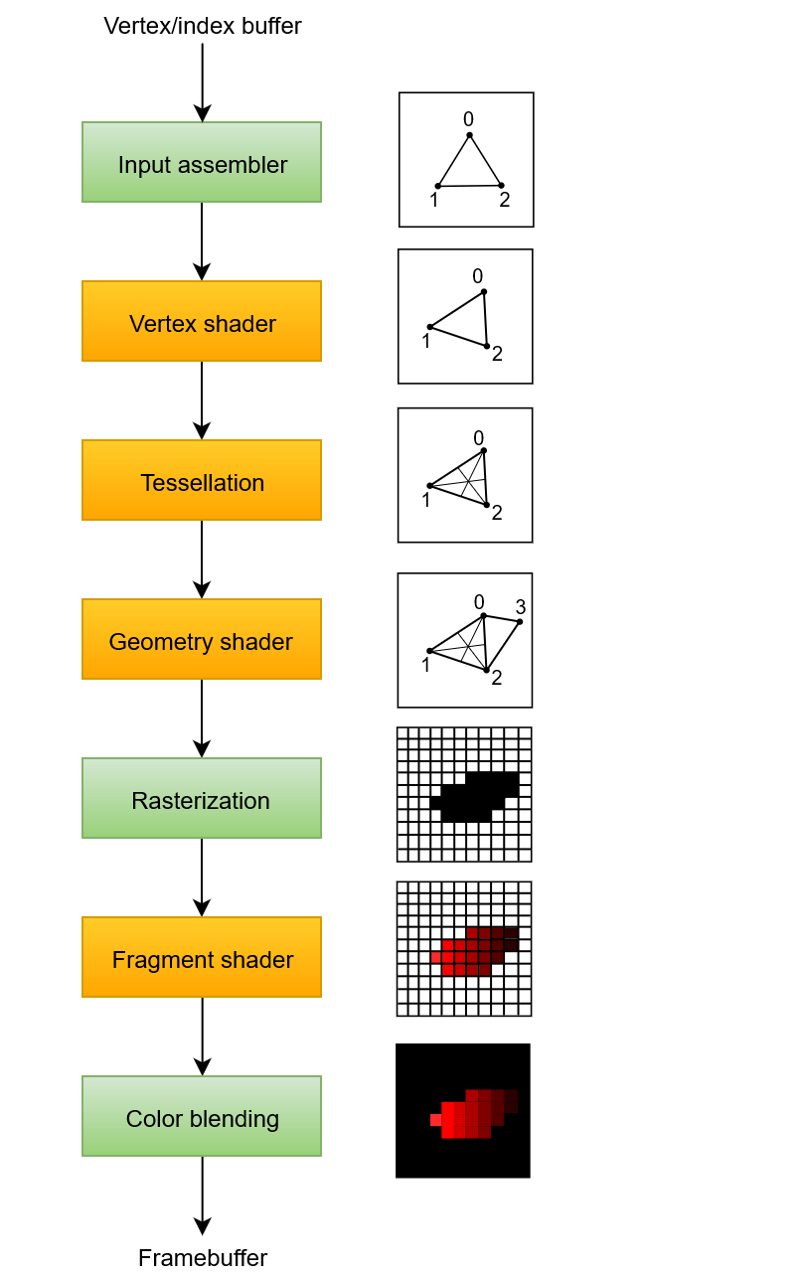

Pipeline overview stages and what they do:
- Input assembler
  - Collects raw vertex data from specified buffers, and may use a separate index buffer to repeat elements without duplicating the vertex data
- Vertex shader
  - Ran for every vertex and usually applies transformations from model space to screen space. Also passes per-vertex data down the pipeline
- Tessellation shader
  - Allows you to subdivide geometry based on rules to increase mesh quality
- Geometry shader
  - Run on every primitive (triangle, line or point) and can discard or output more primitives than input amount.
  - This is not used that much today as the performance is not very good on most GPUs, except on Intel integrated cards
- Rasterization
  - Converts primitives into fragments, this is the pixel elements that are filled on the framebuffer
  - Any fragments outside the screen are discarded
  - Any attributes outputted by the vertex shader are interpolated across the fragment
  - Usually this is where fragments are discarded due to depth testing
- Fragment shader
  - Invoked for every fragment that is not discarded
  - Determines which framebuffers are written to, and with what colour & depth values
- Colour blending
  - Applies operations to mix overlapping fragments, i.e. overwriting each other, adding together or mixing based on transparency
- Green stages are ‘fixed function’ stages and can only have their parameters changed, but the work they do is predefined
- Orange stages are programmable, which just means you upload exactly the code you want the graphics card to apply

The graphics pipeline in Vulkan is completely immutable, so any change like shader input/output, binding different framebuffers or changing the blend function requires a full pipeline recreation. Downside, you need to create pipelines for all combination of states that you need. Upside, since this is setup beforehand the driver can optimize the pipeline much better.

Some of the orange stages are optional, for example tessellation + geometry can be disabled if you are only going to draw simple geometry. Or you can disable the fragment shader stage if you only need depth values, i.e. shadow map creation.

Shader Modules
Instead of using human readable syntax (GLSL / HLSL), Vulkan uses a bytecode format called ‘SPIR-V’. This format can be used to write both graphics and compute shaders.
The downside to using bytecode is that we can’t manually write it, so the Khronos group released a compiler to turn GLSL into SPIR-V. This compiler ensures that your shader code is standard compliant and produces one SPIR-V binary to ship with your application. You can also include this compiler as a library to generate SPIR-V on the fly, rather than having to do it beforehand.

The vertex shader takes in per-vertex attributes (i.e. colour, normals, etc.) and outputs the final position in clip coordinates, as well as attributes for the fragment shader. ‘Clip coordinates’ are a 4d vector this then transformed into ‘normalized device coordinates’, which are mapped from [-1,1] on x & y.
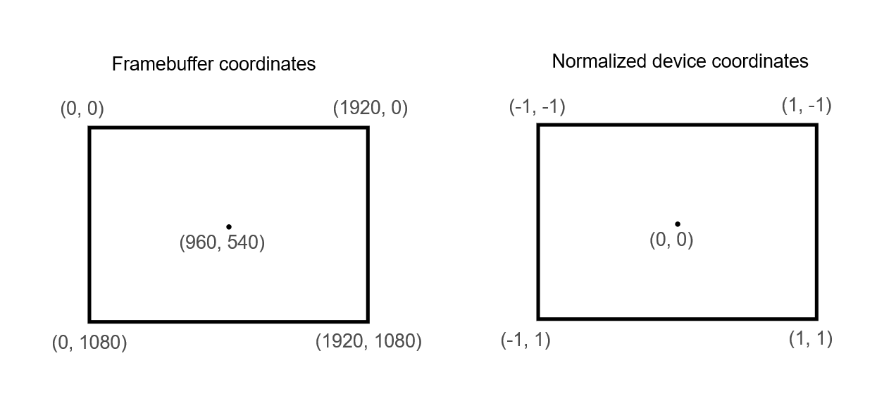

Usually clip space divide x, y, z by w to transform from clip to normalized device space.

The fragment shader outputs a colour and depth for a framebuffer. The colour is a 4d vector that represents (r, g, b, a) and the depth is usually a float. The only other notable thing is that the ‘layout (location = X)’ call specifies which framebuffer index to output to, where X is the index number.

When creating shader stages you can use the member ‘pSpecializationInfo’ to specify values for shader constants. This is so you can use a single shader module that can be configured at pipeline creation, which is more efficient than using variables during render time. This is because the compiler can optimize away any redundant ‘if’ checks.

Fixed Functions
Most of the pipeline state is set in stone (immutable), but some of the state can be changed at runtime. Some of these are the viewport size, line width and blend constants. But you need to specifically tell the pipeline which values are dynamic, they will then be ignored when creating the pipeline and are required to be specified at drawing time. This is most used for the viewport and scissor state.
‘Scissor state’ refers to only rendering to a specific cut-out portion of the render target.

Vertex input struct describes the format of the vertex data that is then passed to the vertex shader. It describes two things:
- Bindings
  - Spacing between data and whether data is instanced or per-vertex
- Attribute descriptions
  - Type of attributes passed to the vertex shader, which binding to load them from and at which offset

Input assembly struct describes what kind of geometry is drawn and if primitive restart should be enabled. The ‘topology’ member can have the following values of ‘VK_PRIMITIVE_TOPOLOGY…’:
- POINT_LIST
  - Points from vertices
- LINE_LIST
  - Line from every 2 vertices without reusing them
- LINE_STRIP
  - The end vertex of every line is used as the start vertex of the next line
- TRIANGLE_LIST
  - Triangle from every 3 vertices without reusing them
- TRIANGLE_STRIP
  - The 2, 3 vertices of every triangle are used as the first 2 of the next
Primitive restart enabled just means that we can use the values of ‘0xFFFF’ or ‘0xFFFFFFFF’ to denote switching between lines and triangles strips in the vertex data.

A viewport describes the region of the framebuffer that will be rendered to, almost always (0, 0) to (window width, window height). It should be noted that swap chain images can differ from the window extents, so we are usually better off using the swap chain extents to match.

A scissor rectangle is basically a clipping mask, any pixels from the viewport that are outside the scissor rectangle will be discarded in the rasterization stage.
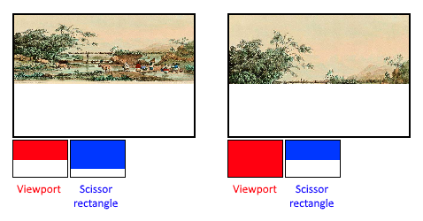
Making viewport and scissors dynamic state is very common, and all implementations can handle this without a performance penalty.

The rasteriser performs depth testing, face culling, and scissor tests. It can also be configured to either output fragments that fill entire polygons, or just the edges (for wireframe rendering). There are a few specific rasteriser configs we care about:
- depthClampEnable
  - If true, any fragments beyond near/far clipping planes have their depth clamped rather than being discarded
- rasterizerDiscardEnable
  - If true, geometry is never passed through the rasteriser, basically disabled output to the framebuffer
- polygonMode
  - VK_POLYGON_MODE_FILL (filled polygons)
  - VK_POLYGON_MODE_LINE (polygon edges are drawn as lines)
  - VK_POLYGON_MODE_POINT (polygon vertices are drawn as points)
- linewidth
  - How thick lines are drawn, this requires the ‘wideLines’ GPU feature
- cullMode
  - Type of face culling to use. Can cull front, back, both, or disable entirely
- frontFace
  - Determines which winding order is considered a ‘front’ face, i.e. clockwise or anticlockwise
- depthBiasEnable
  - The rasteriser can bias the depth value based on a fragments slope. This is sometimes used for shadow mapping, otherwise just disable it

Multisampling works by combining the fragment shader results when multiple fragments output to the same pixel. The is mainly used for anti-aliasing, as if no fragments overlap (only 1 fragment) there are no extra fragment shader results. Much less expensive than rendering to a higher resolution and downscaling. But requires a GPU feature to be enabled to use.

Colour blending is how an outputted fragment shader colour is combined with the colour already in the framebuffer. There are two ways to do it:
- Mix the old and new value for the final colour
- Combine the old and new value using some bitwise operation
There are two types of struct that configure this called ‘VkPipelineColorBlend…’; ‘…AttachmentState’ for configuring per attached framebuffer and ‘…StateCreateInfo’ for configuring a global colour blend.
If the ‘.blendEnable’ is set to VK_FALSE, then the new colour is passed through unmodified with no blending operations applied. The colour blend can also control exactly which channels are blended.

‘Uniforms’ in shaders are global like dynamic state variables, as in they can be changed at drawing time to alter the shader module behaviour, without having to recreate them. Commonly uniforms are used to pass transformation matrices or to create texture samplers. These uniform values need to be specified during pipeline creation.

Render Passes
A render pass object specifies how many colour and depth attachments there are, how many samples to use for each of them, and which rendering operations will be applied to their contents.
The attachment description contains the following data:
- format
  - Usually matches the swap chain image format
- samples
  - specifies how many samples are used, i.e. for multisampling
- loadOp
  - Applies to colour and depth data
  - Specifies what to do with the data before rendering, and can have the following ‘VK_ATTACHMENT_LOAD_OP…’ values:
  - _LOAD (preserve existing contents of the attachment)
  - _CLEAR (clears values to some constant at the start)
  - _DONT_CARE (existing content is undefined, we do not care about it)

- storeOp
  - Applies to colour and depth data
  - Specifies what to do with the data after rendering, and can have the following ‘VK_ATTACHMENT_STORE_OP…’ values:
  - _STORE (rendered contents will be stored in memory, and read later)
  - _DONT_CARE (contents of framebuffer will be undefined)
- stencilLoadOp
  - Same as ‘loadOp’ but only for stencil data
- stencilStoreOp
  - Same as ‘storeOp’ but only for stencil data
- initialLayout
  - Textures and framebuffers are presented by a specific format, but can have their pixel layout changed based on what we are trying to do
  - This specifies the pre-render layout of the pixels in the image and can have the following ‘VK_IMAGE_LAYOUT…’ values:
  - _COLOR_ATTACHMENT_OPTIMAL (images used for colour attachment)
  - _PRESENT_SRC_KHR (images to be presented to the swap chain)
  - _TRANSFER_DST_OPTIMAL (images used as destination for a memory copy operation)
  - _UNDEFINED (we do not care about what previous layout the pixels were in, and we do not care about the image content)
- finalLayout
  - This specifies the post-render layout of the pixels in the image, and can have the same values ‘initialLayout’

A single render pass can have multiple sub-passes that are run sequentially, performing operations that depend on the framebuffer from previous passes. i.e. you can group post-processing effects into one pass, and Vulkan can then reorder operations to conserve memory bandwidth for better performance.
Each sub-pass references one or more attachments, through a ‘VkSubpassDescription’ which has the following members:
- pipelineBindPoint (whether it is a compute or graphics sub-pass)
- colorAttachmentCount (how many colour attachments are there?)
- pColorAttachments (colour attachments array)
- pInputAttachments (attachments read from a shader)
- pResolveAttachments (attachments used for multisampling colour attachments)
- pDepthStencilAttachment (attachment for depth and stencil data)
- pPreserveAttachments (attachments not used for this sub-pass, but their data should be preserved for other sub-passes)

An example of a simple colour attachment reference would be:
VkAttachmentReference colorAttachmentRef = {
.attachment = 0,
.layout = VK_IMAGE_LAYOUT_COLOR_ATTACHMENT_OPTIMAL
};

Which would then translate to the following shader code:
layout (location = 0) out vec4 outColor

The index of the attachment ref directly matches the layout location in the shader.

Drawing

Framebuffers
The attachments specified during render pass creation are bound in a ‘VkFramebuffer’ object. This object references all ‘VkImageView’ objects that represent the attachments. The image that we must use for the attachment depends on which image the swap chain returns to us, so… we need to create a framebuffer for all images in the swap chain and use the correct one when we retrieve an image at drawing time.

Command Buffers
Commands in Vulkan are not executed using function calls, but by ‘recording’ operations into a command buffer object. The advantage of this is when we submit the commands, Vulkan can more efficiently process them as they are all available together.

Commands pools manage the memory that is used to store the command buffers, which are then allocated from the command pools.
Command pools can have two possible ‘VK_COMMAND_POOL_CREATE…’ flags:
- _TRANSIENT_BIT
  - Hints that the command buffers are rerecorded very often
- _RESET_COMMAND_BUFFER_BIT
  - Allow command buffers to be rerecorded individually, without this they must all be reset together
Each command pool can only allocate command buffers that are submitted on a single type of queue, i.e. graphics or presentation queues.

When allocating a command buffer, you can specify a ‘level’, this can have one of 2 values:
- VK_COMMAND_BUFFER_LEVEL_PRIMARY
  - Can be submitted to a queue for execution but cannot be called from other command buffers.
- VK_COMMAND_BUFFER_LEVEL_SECONDARY
  - Cannot be submitted to a queue but can be called from primary command buffers.

When beginning a command buffer, there is a ‘flags’ member that can have the following ‘VK_COMMAND_BUFFER_USAGE…’ values:
- _ONE_TIME_SUBMIT_BIT
  - The command buffer will be rerecorded right after executing it once
- _RENDER_PASS_CONTINUE_BIT
  - This is a secondary command buffer that will be entirely within a single render pass
- _SIMULTANEOUS_USE_BIT
  - The command buffer can be resubmitted while it is pending execution
There is also a ‘pInheritanceInfo’ member that is only relevant to secondary command buffers. It specifies which state to inherit from the calling primary command buffers.
If the command buffer was already recorded, then a call to ‘vkBeginCommandBuffer’ will reset it. It is not possible to append commands to a buffer later.

All functions that record commands can be recognized by their ‘vkCmd’ prefix. They all return ‘void’, so there is no error handling until we finish recording.
The first param of every command is the command buffer to record the command to. The second param specifies the details of the render pass we provide. The final param controls how the command within the render pass will be provided, it can have one of 2 ‘VK_SUBPASS_CONTENTS…’ values:
- _INLINE
  - The render pass commands will be embedded in the primary command buffer, and no secondary buffers are executed
- _SECONDARY_COMMAND_BUFFERS
  - The render pass commands will be executed from secondary buffers

The main draw command is very simple due to how much we specify beforehand. It has the parameters:
- vertexCount (how many vertices are there?)
- instanceCount (how many instances are there?)
- firstVertex (index offset of the first vertex)
- firstInstance (index offset of the first instance)

Rendering and Presentation
Rendering a frame in Vulkan typically has these steps:
- Wait for previous frame to finish
- Retrieve an image from the swap chain
- Record a command buffer
  - Which is where drawing a scene to an image happens
- Submit the recorded command buffer
- Present the image back to the swap chain

In Vulkan synchronization on the GPU is explicit, as in we must define the exact order of operations. i.e. retrieving an image from the swap chain or presenting it back to the swap chain. Each of these operations is started via a single function call, but are executed asynchronously, and as such we need to use sync objects like ‘Semaphores’.
Semaphores have 2 kinds; binary and timeline, and each can be either signalled or un-signalled. Note, by default semaphores are un-signalled. We use semaphores by providing a ‘signal’ one to queue A and a ‘wait’ one on queue B. See below:
VkCommandBuffer A, B = … // record command buffers
VkSemaphore S = … // create a semaphore

// enqueue A, signal S when it is done, do not wait for anything
vkQueueSubmit(work: A, signal: S, wait: None)

// enqueue B, no signalling when it is done, wait on S to start
vkQueueSubmit(work: B, signal: None, wait: S)
A minor note, the call to ‘vkQueueSubmit’ returns immediately and the waiting only happens on the GPU. So, the CPU can continue running without being blocked.
To make the CPU wait, we need a different sync object called a ‘Fence’. A fence is like a semaphore but is for purposely ordering execution on the CPU. Basically, if the CPU needs to know when the GPU has finished something, we use a fence instead.
Like semaphores, fences are either signalled or un-signalled. Whenever we call ‘vkQueueSubmit’ we can attach a fence to the work, which will be signalled only when the work has been completed. One example is taking a screenshot, say the GPU has finished doing the image work and we need to save it to disk, see pseudocode below:
VkCommandBuffer A = … // record command buffer
VkFence F = … // create the fence

// enqueue A, start work immediately, signal F when done
vkQueueSubmit(work: A, fence: F)

vkWaitForFence(F) // blocks execution until A has finished executing

save_screenshot_to_disk() // can’t run until the transfer has finished

Generally, we prefer semaphores so there is not wasted work in waiting. Also, fences must be manually reset. Overall, semaphores are used to specify the execution order on the GPU, while fences are used keep the CPU and GPU in sync with each other.
Newer Vulkan validation layers enforce creating separate ‘render finished semaphores’ for each individual swap chain image, rather than one semaphore for each frame in flight. This is because they are separate systems, you could feasibly have 3 swap chain images but only 2 frames in flight depending on your specific setup.

Sub-passes within a render pass automatically handle image layout transitions using ‘sub-pass dependencies’, which specify memory and execution between sub-passes. There are 2 implicit sub-pass dependencies that handle the transition at the start and end of the render pass. Unfortunately, the one at the start assumes we have acquired the image at that point. To fix this, we can make the render pass wait for the colour attachment output bit stage.
When creating a sub-pass dependency, we can specify a handful of members:
- srcSubpass, dstSubpass
  - Specify indices of dependency and dependent sub-pass
  - ‘VK_SUBPASS_EXTERNAL’ refers to the implicit sub-passes before or after the render pass, src = before, dst = after
  - Index 0 refers to our own sub-pass
  - dstSubpass must always be higher than srcSubpass to avoid cycling
- srcStageMask, srcAccessMask
  - Specify which operations to wait on, and the stages these operations occur in
- dstStageMask, dstAccessMask
  - Specifies the operations that need to wait, and what stage these operations occur in

Swap Chain Recreation
It is possible for the window surface to become incompatible with the swap chain, such as the window resizing or minimization. These events need to be caught, so that we can recreate the swap chain.
The ‘vkAcqueueNextImageKHR’ and ‘vkQueuePresentKHR’ functions can return special values to signify that the swap chain is no longer adequate:
- VK_ERROR_OUT_OF_DATA_KHR
  - The swap chain is incompatible with the surface and can no longer be used for rendering. Usually this is returned when the window resizes.
- VK_SUBOPTIMAL_KHR
  - The swap chain can still be used to present to the surface, but the surface properties no longer exactly match.

Vertex Buffers

Vertex Input Description
Vertex attributes are properties that are specified per-vertex within the vertex buffer, they are usually properties like vertex position and vertex colour.
The ‘layout (location = x)’ assigns indices to inputs so we can later reference them, and importantly some types take up multiple slots. i.e. ‘dvec3’ uses 64-bit vectors, so we need to ensure the next index is at least 2 higher:
layout (location = 0) in dvec3 inPosition;
layout (location = 2) in vec3 inColor;

‘Interleaving vertex attributes’ refers to when vertex data is allocated in one big buffer, one vertex after the other. i.e. if a vertex is a position and colour, then the buffer may look like: [ax, ay, ar, ag, ab, bx, by, br, bg, bb, …]

To tell Vulkan how to interpret this data we need two things:
- Binding Descriptions
  - Specifies at which rate to load data from memory
  - Number of bytes between data entries
  - Whether to move to the next data entry after each vertex or each instance
- Attribute Descriptions
  - How the vertex data should be interpreted
  - For each attribute
    - Binding – from which binding the per-vertex data comes from
    - Location – references the ‘location’ in the vertex shader
    - Format – describes the type of data for the attribute. These use the same enum as colour formats, i.e. vec2 would be specified as VK_FORMAT_R32G32_SFLOAT
    - Offset – specifies the number of bytes since the start of the per-vertex data that the attribute should read from, we can just use ‘offsetof’ macro to get this for us

To setup the graphics pipeline to use this vertex data layout, you just need to set the vertex / attribute count correctly and then bind the descriptors.

Vertex Buffer Creation
Buffers in Vulkan specify regions of memory that we store data to be read by the graphics card. Unlike Vulkan objects, buffers do not automatically allocate memory for themselves.

Buffers only require a few members to create:
- size
  - Size of buffer in bytes
- usage
  - Indicates which purpose the buffer data will be used, i.e. for a vertex buffer you can specify ‘VK_BUFFER_USAGE_VERTEX_BUFFER_BIT’
  - You can specify if a buffer will be multi-purpose by using ^ (xor)
- sharingMode
  - Specifies if the buffer will be exclusive to 1 queue family or shared between multiple
- flags
  - Used to configure sparse buffer memory
  - Default to 0, which means no flags

After creating a buffer, we need to allocate memory for it, by querying the memory requirements using ‘vkGetBufferMemoryRequirements’. This fills a ‘VkMemoryRequirements’ object, which has 3 members:
- size
  - Size of the required memory in bytes (may differ from bufferInfo.size)
- alignment
  - Offset in bytes where the buffer begins in the allocated memory region (this depends on the bufferInfo.usage and bufferInfo.flags)
- memoryTypeBits
  - Bit field of memory types suitable for the buffer

‘VkPhysicalDeviceMemoryProperties’ struct has two arrays:
- memoryTypes
- memoryHeaps
  - Distinct memory resources like dedicated VRAM, and swap space in RAM when VRAM runs out

To copy vertex data into the buffer, we must start by mapping buffer memory into CPU memory via ‘vkMapMemory’. Then memcpy the vertex data into the mapped memory. And finally un-mapping the memory via ‘vkUnmapMemory’.
void* data;
vkMapMemory(device, vertexBufferMemory, 0, bufferInfo.size, 0, &data);
memcpy(data, vertices.data(), (size_t) bufferInfo.size);
vkUnmapMemory(device, vertexBufferMemory);

Unfortunately, the driver may not immediately copy the data into the buffer memory because of things like caching. We can bypass this by using a ‘host coherent’ memory heap, which just means the mapped memory always matches the allocated memory.
Finally, to bind the buffer at draw time, use the command ‘vkCmdBindVertexBuffers’.

Staging Buffer
The vertex buffer works, but it may not be the most optimal memory type for the GPU itself. The most optimal memory has the ‘VK_MEMORY_PROPERTY_DEVICE_LOCAL_BIT’ flag but is not usually accessible by the CPU on dedicated GPUs. To get around this, we can create one ‘staging buffer’ in CPU accessible memory to upload data from the vertex array to, and then a final vertex buffer in device local memory. Then we just need to use a ‘buffer copy command’ to move from the staging buffer to the vertex buffer.
The buffer copy command requires a queue family that supports transfer operations. We do not actually need to check for the transfer flag, as if a queue has the graphics or compute bit flag, it implicitly has the transfer bit already.
To use a staging buffer + vertex buffer combo, you need to specify a host visible buffer as the temporary ‘staging’ buffer and a device local one as the real vertex buffer. There are 2 new buffer usage flags that are required:
- VK_BUFFER_USAGE_TRANSFER_SRC_BIT
  - Buffer can be used as source in a memory transfer operation
- VK_BUFFER_USAGE_TRANSFER_DST_BIT
  - Buffer can be used as destination in a memory transfer operation
Buffers allocated from device local memory usually can’t be mapped to via ‘vkMapMemory’. Instead, we must copy data from one buffer to another, by specifying so using the buffer usage flags.
Memory transfer operations are executed using command buffers, like drawing commands. We use ‘vkCmdCopyBuffer’.
The improvement of doing this, is that the vertex data is being loaded from high performance memory. This does not matter as much for simpler scenes.
It should be noted that calling ‘vkAllocateMemory’ for every individual buffer is not optimal, as there is a ‘maxMemoryAllocationCount’. The correct approach is when allocating memory for a large number of objects is to create a custom allocator that splits up a single allocation among multiple objects by using the ‘offset’ parameter.
There is a ‘VulkanMemoryAllocator’ library that you can use, rather than making your own one.

Index Buffer
An index buffer is used when we want to re-use vertices, i.e. a simple rectangle *can* be specified with 6 vertices (3-per triangle) or using 4 vertices by re-using 2 the corner ones.
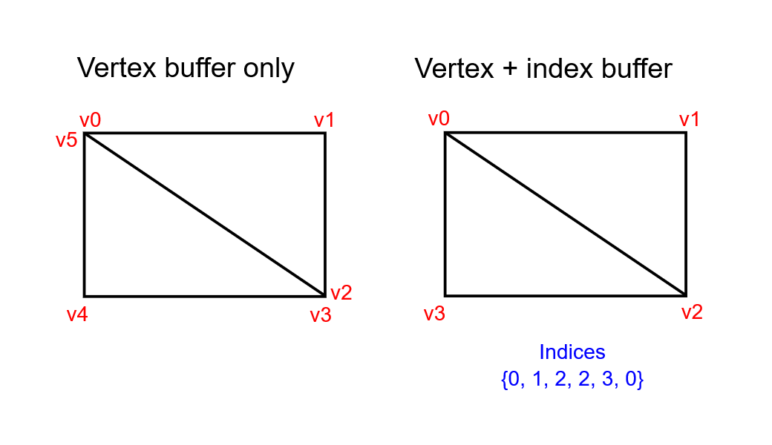

When binding the index buffer for drawing, we can only have a single index buffer. We can not use different indices for each vertex attribute, so we must duplicate vertex data even if a single attribute varies. In simpler terms, you cannot use Vertex 12 for its’ position and Vertex 21 for its’ colour, you can only index one vertex at a time. So, the saving you get by indexing is purely so you do not have to re-specify the individual vertices, you can not save data by re-using individual attributes.

Allocating buffers should be done by allocating multiple resources into a single memory allocation, but you can go a step further. If you store both the vertex and index buffers into a single VkBuffer, you can then use offsets in commands, so your data is more cache friendly.

Uniform Buffers

Descriptor Set Layout and Buffer
If you need some data, or global variables, that update often in Vulkan you use a ‘resource descriptor’. A descriptor is just a way for shaders to freely access resources like buffers and images. Usage of descriptors requires three parts:
- Specify a descriptor set layout during pipeline creation
- Allocate a descriptor set from a descriptor pool
- Bind the descriptor set during rendering
The ‘descriptor set layout’ specifies the resource types that will be accessed by the pipeline.
A ‘descriptor set’ specifies the buffer or image resource that will be bound to the descriptor.
One of the most common descriptors is a ‘uniform buffer object’ (UBO), that is typically used to pass camera related data to the shader. The generic code for a UBO has some struct defined like this:
struct UBO {
glm::mat4 model;
glm::mat4 view;
glm::mat4 proj;
};

And then in the shader, the data is defined like this:
layout (binding = x) uniform UBO {
mat4 model;
mat4 view;
mat4 proj;
} ubo;

In shader code, the order of ‘uniform’, ‘in’ and ‘out’ declarations does not matter.
When defining a descriptor set layout, you need to specify a couple important members:
- binding
  - Matches the ‘binding = x’ declaration in shader code
- descriptorType
- descriptorCount
  - A shader variable can represent an array of objects, so this is the count within that array (or 1, if not an array)
- stageFlags
  - Which stage/s the descriptor is going to be referenced in
  - VK_SHADER_STAGE_ALL_GRAPHICS says it will be used in every stage
- pImmutableSamplers
  - Only relevant for image sampling descriptors
Since the uniform buffers typically get updated every frame, it does not make much sense to use a staging buffer as the performance saving gets lost. For uniform buffers specifically, it is more performant to store the void* mapping for the lifetime of the application (or buffer), this approach is called ‘persistent mapping’.

Descriptor Pool and Sets
Descriptor set layouts describe the type of descriptors that can be bound, but they can not be created directly, they must be allocated from a pool like command buffers, called a ‘descriptor pool’.
To use the descriptor sets, you need to bind them before calling draw commands, using ‘vkCmdBindDescriptorSets’. Unlike vertex / index buffers, descriptor sets can be bound to either graphics or compute pipeline.

Uniforms in C++ must match the uniform in shader code, not only by definition, but also by alignment. For example, these structs match:
struct UBO {
glm::vec2 foo;
glm::mat4 model;
};

layout (binding = 0) uniform UBO {
vec2 foo;
mat4 model;
} ubo;

But if you tried using this uniform, it would not work correctly because the alignment requirements are wrong! In Vulkan, the struct data must be aligned a specific way, i.e.:
- Scalars (floats, etc.) must be aligned by N (usually 4 bytes)
- Vec2 must be aligned by 2N (8 bytes)
- Vec3/4 must be aligned by 4N (16 bytes)
- Mat4 must have the same alignment as a vec4
- Any struct used in a uniform is always 16-byte aligned
- All alignments can be found here
To fix this, it is recommended to always specify ‘alignas’ before new struct members:
struct UBO {
glm::vec2 foo; // implicitly 16-byte aligned
alignas(16) glm::mat4 model;
};

GLM does provide a way to not have to do this, by using ‘#define GLM_FORCE_DEFAULT_ALIGNED_GENTYPES’, but this does not fix it 100% of the time. i.e. nested structs can break this in-built alignment, that is why we manually specify it.

It is possible to bind multiple descriptors sets at once, by specifying a set layout for each set when creating the pipeline layout. Shaders then reference sets like this:
layout (set = 0, binding = 0) uniform UBO { … }

You can then use these multiple sets to have descriptors that vary per-object, and descriptors that are shared be put into separate sets. It should be noted that this is the old way of approaching per-object data as you must allocate a set per-object, update it per-frame, and then bind it per-frame, so it does not scale very well.
Newer, more modern, approaches allocate a single big descriptor set and then simply push an object id to the shader, which is much cheaper. This allocation can also happen a single time if the scene does not spawn any new objects, so instead of updating / binding every frame, you only bind it (potentially) a single time on scene load.
A write descriptor set usually takes this shape in code:
// This is used to update the configuration of descriptors
VkWriteDescriptorSet descriptorWrite = {
.sType = VK_STRUCTURE_TYPE_WRITE_DESCRIPTOR_SET,

// Descriptor set to update, and at what binding
.dstSet = mDescriptorSets[i],
.dstBinding = 0,

// Descriptor sets can be arrays, this is the element index
.dstArrayElement = 0,

// How many descriptors to update, starting from array
// element index, and what type those descriptors are
.descriptorCount = 1,
.descriptorType = VK_DESCRIPTOR_TYPE_UNIFORM_BUFFER,

// Descriptors that refer to image data
.pImageInfo = nullptr, // optional

// Descriptors that refer to buffer data
.pBufferInfo = &bufferInfo,

// Descriptors that refer to buffer views
.pTexelBufferView = nullptr // optional
};

Texture Mapping

Images
To add textures to a Vulkan application you need to follow these steps:
- Create an image object on device memory
- Fill object with pixels from an image file
- Create an image sampler
- Add a combined image sampler descriptor to sample colours from a texture
Just like vertex buffers, we should create a staging buffer and then copy the image data to a device local buffer. Note, you can create a ‘staging image’, but copying from a buffer is faster on some hardware.
Images can have different layouts that affect how pixels are organized in memory. Each layout is optimal for a different use-case:
- VK_IMAGE_LAYOUT_PRESENT_SRC_KHR
  - For presentation
- VK_IMAGE_LAYOUT_COLOR_ATTACHMENT_OPTIMAL
  - As attachments for writing colours from the fragment shader
- VK_IMAGE_LAYOUT_TRANSFER_SRC_OPTIMAL
  - As source in a transfer operation, like ‘vkCmdCopyImageToBuffer’
- VK_IMAGE_LAYOUT_TRANSFER_DST_OPTIMAL
  - As destination in a transfer operation, like ‘vkCmdCopyBufferToImage’
- VK_IMAGE_LAYOUT_SHADER_READ_ONLY_OPTIMAL
  - For sampling from a shader
Commonly, transitioning an images layout is done through a ‘pipeline barrier’, which are used primarily to synchronize access to resources. i.e. making sure an image was written to before we try to read it, or to transition layouts.
A very common library to load images is ‘stb_image’ which is a single header library that you can find here.
Technically you can set up the shader to directly access pixel data that is in a buffer, but it is easier (and faster) to use a ‘VkImage’ object. Pixels within this object are known as texels and can be retrieved using 2d coordinates.
The image create info has a couple special values:
- tiling
  - VK_IMAGE_TILING_LINEAR – texels are laid out in row-major order like in a pixel array
  - VK_IMAGE_TILING_OPTIMAL – texels are load out in some optimal access variation
  - The tiling mode cannot be changed later, so if you need explicit access to the texels of an image, you must use ‘_LINEAR’
- initialLayout
  - VK_IMAGE_LAYOUT_UNDEFINED
    - Not usable by GPU and the first transition will discard texels
  - VK_IMAGE_LAYOUT_PREINITIALIZED
    - Not usable by GPU, but the first transition preserves texels
The most common way to do layout transitions is using an ‘image memory barrier’. Which is a specialized pipeline barrier for synchronizing access to resources, i.e. ensuring writing has finished before reading. There is an equivalent barrier for a buffer called a ‘buffer memory barrier’.
There is an image layout that supports all operations, ‘VK_IMAGE_LAYOUT_GENERAL’, but it doesn’t offer the best performance for any one operation. It should generally only be used for very special cases, i.e. using an image as input and output in transitions.

Debugging Non-Destroyed Objects
If you need to debug which specific object is not being cleaned up correctly, Vulkan will output the type name, i.e. ‘VkDeviceMemory’. You then can attach a ‘debug utils object name info’ object like so:
// Name object for debugging
VkDebugUtilsObjectNameInfoEXT nameInfo = {
.sType = VK_STRUCTURE_TYPE_DEBUG_UTILS_OBJECT_NAME_INFO_EXT,
.objectType = VK_OBJECT_TYPE_DEVICE_MEMORY,
.objectHandle = (uint64_t)mTextureImageMemory,
.pObjectName = "Debug Object Name"
};
SetDebugUtilsObjectNameEXT(mInstance, mLogicalDevice, &nameInfo);

This will then output something like the following if it did not clean up correctly:
Object Tracking - … VkType 0xSomeMemoryAddress[DebugObjectName]

Texture Image View
While shaders can read texels directly from images, it is very uncommon, they are usually accessed through samplers. These samplers apply filtering and transformations to compute the final colour that the shader accesses.
Oversampling is when you have more fragments than texels, so you end up with a blocky mess, but this can be solved with filtering. Filtering example below:
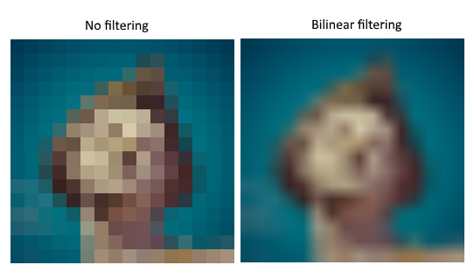
A sampler object will automatically apply this filtering for you when reading colour from a texture.

Under-sampling is the opposite, when you have more texels than fragments, resulting in blocky edges specifically. The solution to this problem is to use anisotropic filtering, which again can be applied automatically by a sampler object.
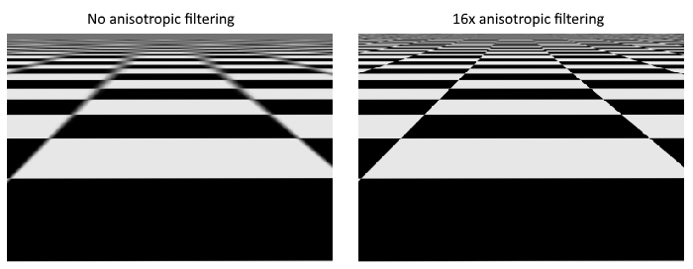

Aside from different types of filtering, a sampler can apply certain transformations when trying to read texels outside of an image through its’ ‘addressing mode’. The main possibilities are below:
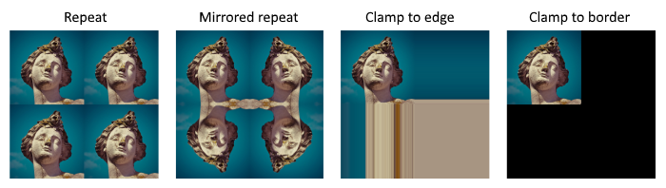

When creating a texture sampler, it is not attached to / nor references a VkImage object. This is because the sampler provides an interface to extract colours from textures and can then be applied to any image / texture you want. This is a standout feature from older APIs where images and filtering were defined in a single state.
Anisotropic filtering is an optional device feature. If you want to use it, you need to request it when creating the logical device like so:
VkPhysicalDeviceFeatures deviceFeatures = {};
deviceFeatures.samplerAnisotropy = VK_TRUE;

Even though basically every card supports it, it is also a good idea to check if anisotropic filtering is available in an ‘IsDeviceSuitable’ function.

Combined Image Sampler
A ‘combined image sampler’ is another type of descriptor, that makes it possible for shaders to access some image resource through a sampler object.
The ‘stageFlags’ when creating the descriptor set layout is usually set to fragment bit, for sampling textures, but it can also be used in the vertex stage for deformations like heightmaps.
To use a combined image sampler in shader code you need to use the following:
layout (binding = x) uniform samplerYD texSampler;

As always ‘binding = x’ should correspond to the set binding in the descriptor set layout, and ‘samplerYD’ can be sampler1D, sampler2D or sampler3D from setup.

Depth Buffering
Typically, depth becomes an issue when fragments are drawn over the top of others simply because they are drawn last. This is solved view 2 ways:
- Sort draw calls by depth (back to front)
- Use depth testing with a depth buffer
The first approach is usually for handling transparent objects as depth does not really exist for transparent objects. The second approach is the most common way of handling depth-based rendering for non-transparent objects.
A depth buffer is an additional attachment that only stored depth values and is used by the rasteriser whenever it produces a fragment. The rasteriser performs a simple check by using a comparison operation, the result determines whether the fragment is drawn at all. For instance, if you set the depth comparison op to less than, fragments will only be drawn if their depth value is less than that of the current depth value. If the depth test fails, it usually just discards the fragment.
For use with GLM, we need to define ‘GLM_FORCE_DEPTH_ZERO_TO_ONE’ as by default it uses the OpenGL depth of [-1..1], but we need [0..1] in Vulkan.
The format for the depth texture does not need to be a specific format as we are not directly accessing the texels. It just needs reasonable accuracy; programs usually use 24-bits for accuracy in real-world applications. There are a couple to choose from:
- VK_FORMAT_D32_SFLOAT
  - 32-bit float for depth
- VK_FORMAT_D32_SFLOAT_S8_UINT
  - 32-bit signed float for depth and an 8-bit stencil component
- VK_FORMAT_D24_UNORM_S8_UINT
  - 24-bit float for depth and an 8-bit stencil component
You do not explicitly need to transition the depth image because the render pass can take care of that for us. It is still possible to do this manually if you like.

Loading Models
The most common way of loading models is through a *.obj file, using a library like tinyobjloader, which you can get here. It should be noted that if you require anything remotely more complex than simply defining vertices / indices, than the OBJ format will not work, i.e. it does not support skeletal animation. For simple programs OBJ is fine.
An OBJ file consists of positions, normals, texture coordinates (UVs) and faces. Faces consist of some number of vertices, where each vertex contains data by index, this makes it possible to re-use attributes not just vertices.
The attrib container holds all attributes (positions, normals, UVs). The shapes container holds all separate objects and their faces. OBJ models can also define a material and texture per-face.
It should be noted that the LoadObj function of tinyobj defaults to triangulating faces.
A tinyobj::index_t contains the vertex_index, normal_index and texcoord_index which we can use to look up individual vertex attributes like so:
vertex.texCoord = {
attrib.texcoords[2 * index.texcoord_index + 0],
attrib.texcoords[2 * index.texcoord_index + 1]
}

The OBJ format assumes the vertical coordinate of ‘0’ means the bottom of the image, but in Vulkan it is typically the opposite. We just need to flip the vertical component of the texture coordinate like this:
vertex.texCoord = {
attrib.texcoords[2 * index.texcoord_index + 0],
1.f - attrib.texcoords[2 * index.texcoord_index + 1]
}

Mipmaps
What are mipmaps? They are pre-calculated, downscaled versions of a texture. Each ‘level’ of a mipmap is half the size of the previous one, with level 0 being the original image texture. Mipmaps are used as a form of ‘level of detail’ (LOD), on top of mesh LODs. Objects further away from the camera will sample from further mipmap levels, an example of a mipmap is below:

In Vulkan, each ‘mip level’ after 0 is referred to as the ‘mip chain’. The number of mip levels is set when a VkImage is created and can easily be determined by using log2.
To generate mip levels, we use the ‘vkCmdBlitImage’ command. This command performs the copying, scaling, and filtering operations. We simply call this command for each level to ‘blit’ the data to our texture image. This command is a transfer operation, so we must tell Vulkan by setting the texture image as both a transfer source and destination.

Linear filtering is not guaranteed to be supported on all platforms, so when generating mip levels we should always double check that the specified image format supports linear filtering by querying the physical device properties.

The VkImage holds the mipmap data, but the VkSampler controls how that data is read during rendering. Vulkan lets us specify minLod, maxLod, minLodBias and mipmapMode. The sampler selects the correct mip level based on these pre-set values.
If you want to visualize higher mip levels, you can increase ‘minLod’ to skip low levels.

Multisampling
One very common, undesirable, effect is when geometry must be rendering using a limited number of pixels. This creates jagged edges when viewed from certain angles, which is almost never wanted.
A way to solve this problem is to use multi-sample anti-aliasing (MSAA), which samples multiple point per pixel and then blends them together. This creates a smoother looking effect to hide the jaggedness:
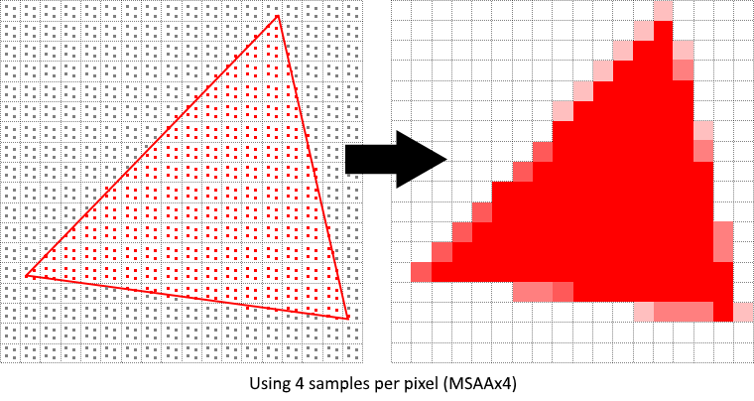

In MSAA, sampling happens in an offscreen buffer and then is resolved to the default framebuffer. We need to keep a separate render target to sample from, like how we store the depth image. This render target does *not* need any mip levels.
When creating the normal colour attachment, we can not use the ‘_PRESENT_SRC_KHR’ layout and instead need to use ‘_COLOR_ATTACHMENT_OPTIMAL’ layout. This is because multi-sampled images need to first be resolved to a regular (not multi-sampled) image first before being presented to the screen. The depth attachment does not need to be changed as it is never presented to the screen to begin with.
We must create a separate ‘resolve attachment’ to let the render pass know that we want to resolve the multi-sampled image into a regular attachment. And then in a sub-pass we point to the resolve attachment reference.
Since we re-use the MSAA colour image, we must set the sub-pass dependency to wait for colour attachment writes to finish before performing subsequent writes like so:
...
dependency.srcAccessMask = VK_ACCESS_COLOR_ATTACHMENT_WRITE_BIT
| VK_ACCESS_DEPTH_STENCIL_ATTACHMENT_WRITE_BIT;
...

The only downside of MSAA is it only smoothens out the edges of geometry, not the interior lines. So, for example, if you have a texture with highly contrasting colours, it will not smooth out the actual edges in the texture. This can be kind of solved by enabled ‘sample shading’ which improves image quality but at an additional cost.
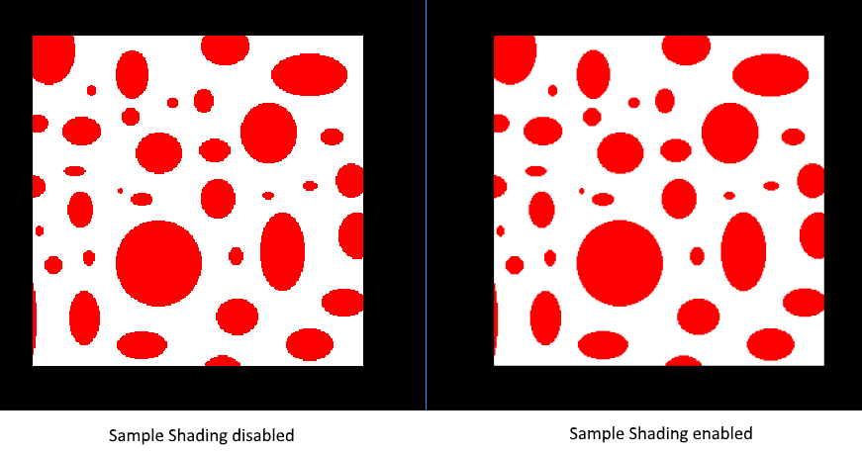
To enable this, you need to enable it in the logical device features, and in the pipeline multi-sample create info. Like so:
void CreateLogicalDevice() {
…
// Enable sample shading feature for the device
deviceFeatures.sampleRateShading = VK_TRUE;
…
}

void CreateGraphicsPipeline() {
…
// Enable sample shading in the pipeline
multisampling.sampleShadingEnable = VK_TRUE;

// Min fraction for sample shading, closer to 1.0 is smoother
multisampling.minSampleShading = .2f;
…
}

Push Constants
Push constants are tiny, extremely fast blocks of shader-visible data that are written directly into the command buffer and read without the use of descriptor sets. They are used for small, frequently changing data, i.e. per-draw or per-frame values.
TDLR:
- Small shader readable memory bank (minimum 128 bytes guaranteed by Vulkan)
- Stored inside the command buffer, not in GPU memory
- Updated using ‘vkCmdPushConstants’, which copies data directly into the push-constant range
- Accessible by any shader stage (defined of course by the pipeline layout)
Common use cases are:
- Object / world transforms
- Material parameters (colour, roughness, texture index, etc.)
- Instance IDs or indices into bindless arrays
- Flags, bools, small structs that don’t require a UBO
Basically, “use push constants for tiny, frequently updated values and use buffers for anything larger / less dynamic”.

In modern game engines the transforms are usually setup in the following way:
Camera transform | UBO, as it only updates once per-frame, not per-draw call
Object transform (small scene) | Push constant, as it is simple and has minimal overhead
Object transform (large scene / scalability is required) | SSBO + push constant for the object index. All object data is bound once, and then only a tiny integer is pushed to the shader

SSBO
A shader storage buffer object (SSBO) is a GPU buffer that shaders can both read/write to, they can be as big as the VRAM allows and can contain unsized arrays! This is the exact opposite of a UBOs, which are small, read-only and are very strict on alignment.
SSBO’s in shader code are declared somewhat like below:
layout (set = x, binding = y) buffer StorageBufferObject {
vec4 data[];
};
In this example, the SSBO contains an unsized array of vec4 data.
They are commonly used for:
- Storing all object transforms, then indexing by some object id
- A material table, then using push constants to access by ‘material id’
- Compute shader data (i.e. GPU accelerated particle systems)

What is the difference between UBOs and SSBOs? The former is heavily cached, and are broadcast friendly, meaning the GPU stores it in a special hardware cache and when it is accessed, the data is broadcast to everywhere that needs it. Also, the max size of the UBO data is very small, most often only 64 KB!
SSBOs on the other hand are stored in VRAM, and as such are only size limited by how much the user’s system has available, which could be multiple GB! They also use a more tightly packed data layout with minimal padding, saving on memory.
In short, use UBOs for small constant data across a frame and SSBOs for large buffers that might need reading & writing.

So, common data patterns:
- UBO Per-frame constants (camera, lighting, etc.)
- SSBO Per-scene data (object transforms, materials, etc.)
- Push Constants Per-draw parameters (object id, material id, etc.)
- Bindless Textures
  - This is achieved by creating a descriptor set layout binding with X ‘descriptorCount’ within a descriptor set, and then binding that descriptor set once per-frame
  - We then index into this sampler ‘array’ by using an integer, typically through a material within an SSBO or push constant per-object
  - To ‘load’ a texture into the ‘array’ we must write to it, and then update the descriptor set via ‘vkUpdateDescriptorSets’

